Composite carbon nano fibre based aerogels
Dr.N.Gokarneshan¹ and Dr.C.Premalatha²
¹ Departmennt of Textile Chemistry, SSM College of Engineering, Komarapalayam, Tamil Nadu, India.
² Department of Textile Technology, KSR College of Technology, Tiruchengode, Tamil Nadu, India.
advaitcbe@rediffmail.com ; +919677756622
Abstract
This article provides an overview on manufacturing composite carbon nanofiber-based aerogels through freeze casting technology. As known, freeze casting is a relatively new manufacturing technique for generating highly porous structures. During the process, deep cooling is used first to rapidly solidify a well-dispersed slurry. Then, vacuum drying is conducted to sublimate the solvent. This allows the creation of highly porous materials. Although the freeze casting technique was initially developed for porous ceramics processing, it has found various applications, especially for making aerogels. Aerogels are highly porous materials with extremely high volume of free spaces, which contributes to the characteristics of high porosity, ultralight, large specific surface area, huge interface area, and in addition, super low thermal conductivity. Recently, carbon nanofiber aerogels have been studied to achieve exceptional properties of high stiffness, flame-retardant and thermal-insulating. The freeze casting technology has been reported for preparing carbon nanofiber composite aerogels for energy storage, energy conversion, water purification, catalysis, fire prevention etc. This review deals with freeze casting carbon nanofiber composite materials consisting of functional nanoparticles with exceptional properties. The content of this review article is organized as follows. The first part will introduce the general freeze casting manufacturing technology of aerogels with the emphasis on how to use the technology to make nanoparticle-containing composite carbon nanofiber aerogels. Then, modeling and characterization of the freeze cast particle-containing carbon nanofibers will be presented with an emphasis on modeling the thermal conductivity and electrical conductivity of the carbon nanofiber network aerogels. After that, the applications of the carbon nanofiber aerogels will be described. Examples of energy converters, supercapacitors, secondary battery electrodes, dye absorbents, sensors, and catalysts made from composite carbon nanofiber aerogels will be shown. Finally, the perspectives to future work will be presented.

Biography
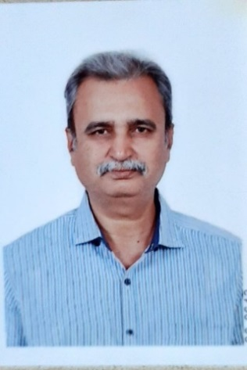
Dr.N.Gokarneshan was born in 1964. He obtained his PhD in textile technology from Anna University, Chennai, India in 2008. He has academic experience spanning over 25 years and industrial experience spanning over 10 years. He has worked in a number of premier acadenuc institutions and held various positions such professor, head of department, dean and principal. He is presently working as Professor and head at the department of Fashion design and arts in the Hindustan Institute of Technology and Science, Chennai, India. He has made many contributions in his field. He has authored 15 books, published over 200 papers in various leading journals, contributed many book chapters and presented papers in conferences. His recognitions include editorial board membership and peer reviewer in journals. Besides, he has also been organizing committee member in a number of conferences. He is a recipient of a number of awards and recognitions for his outstanding contributions in field. He has organized many seminars, workshops and symposiums. He has been a resource person in a number of technical webinars. He has been a resource person for faculty development programs. He has taught at undergraduate and post graduate levels in various academic institutions. His noteworthy contributions include paper publications in top grade SCI, SCOPUS and WEB OF SCIENCE journals, books and book chapters with prestigious publishers like WILEY, ELSEVIER, SPRINGER NATURE, SAGE, TAYLOR AND FRANCIS.
His areas of interest include Medical textiles, Textile composites and Nano technology in textiles.
Details of presenting author to be mentioned in certificate:
Name: Dr.N.Gokarneshan and Dr.C.Premalatha
Affiliation: Department of Textile Chemistry, SSM College of Engineering
Department of Textile Technology, KSR College of Technology
Country: India.

