Presentation Title
Author name and Co-author names
Department, Affiliations or Organisation, City, state, Country, Email address, Phone
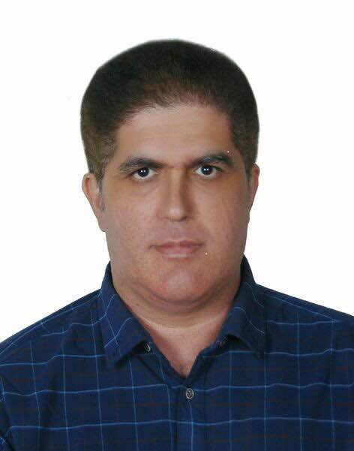

Presenter Name:Dr Pedram Moeini(MD,Neurologist,Homeopath)
Department of Neurology
Isa Ibn Maryam Hospital
Isfahan university of medical sciences
Isfahan, Iran
Email:

p.moeini@mail.mui.ac.ir pmoeini@yahoo.com

Phone Number:+3132351416 Mobile: +989131147431
Abstract: Short description of the presentation topic about 250 to 600 words.
Title: Can homeopathy be an effective alternative treatment for preventing medical overuse headaches?
-Medical overuse headache (MOH) stands as a formidable obstacle in the therapeutic landscape of migraine and cluster headache, marked by the paradoxical exacerbation of symptoms due to frequent use of conventional medications. While classical medicine typically leans on suppression therapy to manage acute attacks, its efficacy is often shadowed by concerns surrounding medication dependency and adverse effects. Conversely, homeopathy presents a compelling alternative, embracing a holistic paradigm that addresses the root causes of headache disorders while minimizing reliance on pharmacological interventions.

This abstract ventures into the realm of comparing the privilege of homeopathy over classical medicine in the prevention of MOH within the contexts of migraine and cluster headaches. Leveraging a thorough synthesis of existing literature and clinical studies, we meticulously evaluate the efficacy, safety, and patient-reported outcomes associated with homeopathic remedies vis-à-vis traditional approaches. Moreover, we embark on an exploration of the fundamental principles underpinning homeopathy, particularly its emphasis on individualized treatment regimens and the stimulation of the body's innate healing mechanisms.

By delving into the nuanced mechanisms of action and potential advantages of homeopathy, this abstract elucidates its promising role in averting the perils of MOH while nurturing a holistic state of well-being. The intrinsic flexibility of homeopathic interventions enables tailored solutions that resonate with the unique symptomatology and sensitivities of each patient, fostering a therapeutic alliance grounded in personalized care and patient empowerment.

This discourse not only underscores the imperative of integrating homeopathy into the multifaceted landscape of headache management but also underscores the exigency for further empirical research to validate its efficacy and guide evidence-based clinical practice. As such, this abstract endeavors to equip healthcare practitioners with the requisite knowledge to navigate the complex terrain of MOH prevention, while empowering patients to actively engage in informed decision-making regarding their healthcare journey in the realms of migraine and cluster headache management.

Biography of Presenter about 100 words:
-
Personal Statement:
Dr. Pedram Moeini is a highly experienced neuroscience researcher and clinical neurologist with a passion for his work. With over ten years of experience as a neuroscience researcher and twelve years as a general practitioner and Homeopath, he has treated over 100,000 patients in various settings. Dr. Moeini has also taught neuropsychology and psychoneuroimmunology at Najafabad Azad University of Medical Science

Professional Experiences:
• Neurologist at Isa Ibn Maryam Hospital Esfahan university of medical sciences , Esfahan,Iran from 2022. (Neurology team manager).
• Neuropsychology and psychoneuroimmunology professor at Najafabad Azad University of Medical Science, Esfahan, Iran from 2022.
• Neurologist in a private office in Esfahan from 2019.
• Neurologist at Saadi Hospital,Esfahan,Iran from 2019.
• Neurologist at Dr. Moaven Hospital in Sahne City, Kermanshah state, Iran from 2017 to 2019.
• Specialist training (Neurology Residency) at Esfahan University of Medical Science from 2013 to 2017.
• General practitioner and Homeopath in a private office from 2003 to 2013.
• Teaching Homeopathic courses in institutes in Iran (Member of the Iranian Homeopathic Association) from 2003 to 2010.
• General practitioner in Komshecheh and Habibabad Cities (a rural location near Esfahan) from 2000 to 2003.
• General medical (MD) student training (General Practitioner) from 1992 to 2000 at Esfahan University of Medical Science
Education:
• Specialist training (Neurology) at Esfahan University of Medical Sciences from 2013 to 2017.
• General medical school training (MD) at Esfahan University of Medical Sciences from 1992 to 2000
• Corresponding course in the diploma of practitioner level, advanced case taking and repertorisation, and clinical internship in Homeopathy (Alternative medicine) from the British Institute of Homeopathy (2002-2004). ( https://bihint.com/)

Research and Publications:
• Etemadifar M, Moeini P, Nabavi S. Fingolimod versus High Dose Interferon Beta-1a in Multiple Sclerosis: A Randomized Clinical Trial. Caspian J Neurol Sci. 2017;3(1):1-8. DOI: 10.18869/acadpub.cjns.3.8.1
• [Google Scholar]
• Farrokhi M, Moeini P, Fazilati M, Nazem H, Faraji S, Saadatpour Z, Fadaei E, Saadatpour L, Rezaei A, Ansaripour S, Amani-Beni A. Polymorphisms in CD14 Gene May Modify Soluble CD14 Levels and Represent Risk Factors for Multiple Sclerosis. Immunological Investigations J. November 2016;45(8):738-745. DOI: 10.1080/08820139.2016.1226897
• [Google Scholar][Pubmed]
• Farrokhi M, Saadatpour Z, Fadaee E, Saadatpour L, Rezaei A, Moeini P, Amani Beni A. A Novel Approach to Discriminate Subgroups in Multiple Sclerosis. Iranian Journal of Allergy, Asthma, and Immunology. December 2016;15(6):536-546.

[Google Scholar] [Pubmed}
• Etemadifar, M., Moeini, P., Masoumi, S., Bagheri-Ghalehsalimi, A., Alavi, A., Fereidan-Esfahani, M. A Case-Control Study on Risk Factors in Pediatric Multiple Sclerosis Population, Isfahan Province, Iran: Highlighting the Role of Puberty. Journal of Isfahan Medical School, 2017; 35(424): 335-339.
•
• Reaserchgate: www.researchgate.net/profile/Pedram-Moeini-3
• linkedin: https://www.linkedin.com/in/dr-pedram-moeini-0a869263
• Google Scholar: https://www.scholar.google.com/citations?user=InNmQXQAAAAJ&hl=en

Details of the presenting author to be mentioned in the certificate:
Name: Dr Pedram Moeini
Affiliation: Neurologist, Homeopath
Country: Iran
- Please attach a recent high-resolution photograph of the presenting author.

