Research into complexes of triethanolamine with ZnCl₂ and CdCl₂
using quantum chemistry and NMR methods.

Vladimir Voronov.

Irkutsk national research technical university, Irkutsk, Russia;
Irkutsk institute of chemistry, Siberian branch of the Russian academy of sciences,
Irkutsk, Russia.
E-mail address: vladim.voronov1945@yandex.ru

Complexes of triethanolamin with ZnCl₂ and CdCl₂ were studied using the methods of quantum chemistry and NMR spectroscopy. Triethanolamine complexes are prone to ligand exchange, which make them suitable as metal transporters. Therefore, research into the biological action of such compounds is of particular importance. Non-empirical quantum-chemical calculations were performed by the B3LYP method using the Gaussian 09 software package. The obtained experimental data indicate that changes in the NMR spectrum shifts are accompanied by an increase in the spin-spin coupling constants, with the ¹J (C, H) constants of the methylene group associated with nitrogen being the most significant. On the basis of the conducted NMR spectrum analysis, the authors propose a scheme for describing the structure and intermolecular dynamics of the complexes under study. In order to elucidate the observed changes in the NMR spectra of triethanolamine in the process of complex formation, a series of quantum-chemical calculations was carried out. According to the obtained theoretical and experimental results, the complexes under study are characterized by intermolecular metabolic processes that lead to the averaging of NMR signals from various compounds existing in the solution. For triethanolamine complexes with CdCl₂, the existence of bi- and tricyclic forms is equally probable. For triethanolamine complexes with ZnCl₂, the tricyclic form seems to be more beneficial.
Voronov V.K., Dudareva O.V., Funtikova E.A. Research into complexes of triethanolamine with ZnCl₂ and CdCl₂ using NMR Spectroscopy and Quantum Chemistry methods. Proceedings of Universities. Applied Chemistry and Biotechnology. 2020, vol.10(4), p. 548–555.

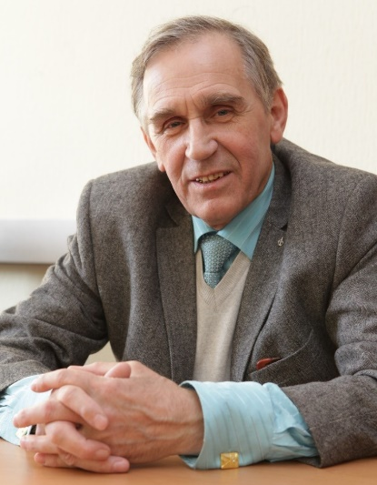
Professor Vladimir Voronov's research interests are related to solving problems of molecular spectroscopy and physico-organic chemistry by methods of nuclear magnetic resonance and quantum chemistry. In addition, for the last twenty years or so, his research interests have included scientific and methodological issues related to cognitive barriers of university students. He is the author of more than three hundred publications in periodicals, including more than thirty books. He received a number of awards established by the Russian Academy of Natural Sciences, including the Gold Medal "For innovative work in the field of higher education". Member of the American Chemical Society.

