Carbon Chemistry World Conference CCWC 2024

Precision Global Conferences cordially invites you to our conference Carbon Chemistry World Conference, CCWC 2024, from 17 to 19 August 2024, in Barcelona, Spain.
Conference theme: “Carbon Chemistry World Conference CCWC 2024.”

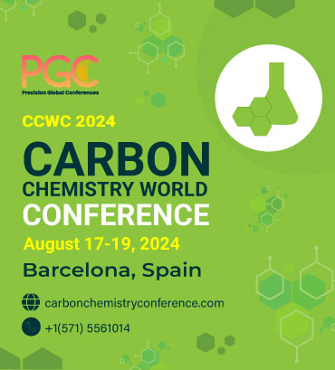

Carbon Chemistry World Conference, CCWC 2024,17 to 19 August 2024, in Barcelona, Spain, seeks to serve as a pivotal global gathering for some of the most brilliant minds in the field. This conference acts as a crucible for exchanging innovative ideas and exploring diverse applications within carbon chemistry.
CCWC 2024's primary objective is to promote scientific rigor within the global scientific community and stimulate research across various carbon chemistry domains, including the study of hydrocarbons, investigations into novel carbon alloys, exploring cutting-edge carbon fiber technologies, and application of quantum chemistry principles. These diverse focus areas hold immense promise and relevance for various vital industries, including chemicals, pharmaceuticals, and manufacturing sectors.
CCWC 2024 endeavours to create a fertile ground for enriching knowledge and intellectual progress. Attendees can look forward to engaging in interactive sessions, discussions, and presentations, laying the groundwork for scientific collaboration in carbon chemistry.

Chemistry Conferences 2024, Chemistry Conference Spain, Chemistry Conference Europe, Organic Chemistry Conference, Organic Chemistry Conferences, Organic Chemistry Conference 2024, Organic Chemistry Conference Spain, carbon chemistry conference Europe, carbon chemistry conferences, Carbon Chemistry Conference 2024, carbon chemistry conference Spain, chemistry world conferences, Organic Chemistry Conferences 2024, Analytical Chemistry Conferences, Chemistry Conference, Chemical Reaction Engineering Conference, Chemical Reaction Engineering Conference, Organic Chemistry Conferences, Chemical Engineering Conferences, Chemistry 2024, Organic and inorganic Chemistry Meetings, Theoretical Chemistry Conferences, Synthetic Chemistry Conferences, Agricultural Chemistry Conferences, Organometallic Chemistry Conferences, Nano Carbon Conference 2024, Quantum Chemistry Conference 2024, Materials Chemistry Conference, Materials Chemistry Conference, 2024, Carbon Chemistry Conference Europe 2024.

For more information: https://www.carbonchemistryconference.com/
For Abstract Submission: https://www.carbonchemistryconference.com/abstract-submission.php
To register: https://www.carbonchemistryconference.com/registration.php
Reach out at: chemistry@pgconferences.com
Organiser:
Precision Global Conference: https://precisionglobalconferences.com/
Address: 601 King St Ste 200 #853 Alexandria, VA 22314 United States
Email:chemistry@pgconferences.com
Phone: +1-571-5561014

