2nd Edition of Neurology World Conference NWC 2024

Precision global Conferences cordially invite you to our conference Neurology World Conference (NWC 2024) HYBIRD EVENT Date September 4 to 6, 2024, in San Francisco, CA, USA.
Conference theme: “Recent Advances in Brain & Neurological Disorders and Treatment.”
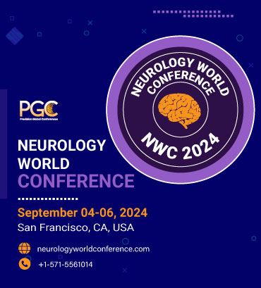
2nd Edition of Neurology World Conference, September 4 to 6, 2024, in San Francisco, CA, USA, focuses on the crucial progression of innovations and breakthroughs through cutting-edge neurology research and practice. We aim to explore the new streamlines in the field and bridge neuronal Shortfalls in the industry. Neurology World Conference focuses on the crucial progression of innovations and breakthroughs through cutting-edge neurology research and practice. We aim to explore the new streamlines in the field and bridge neuronal Shortfalls in the industry.
NWC 2024 agenda mainly focuses on bringing on neurologists, neuro specialists, neuro physicians, academicians, medical professionals, and industry specialists from all the multi-disciplines to join us. We invite you to disseminate the most recent findings among your colleagues. The upgrading technology and fast-paced lifestyles are diluting the mental health of people these days, giving rise to many such neurological diseases. Over the past 25 years, there has been an increase in neurological illnesses that cause illness, death, or long-term disability worldwide. Because of these problems, mortality rates are rising daily among people worldwide.
neurology conferences| neurology conferences 2024| world congress of neurology 2024| international neurology conferences 2024| world neurology conferences 2024| virtual neurology conferences 2024| online neurology conferences| neurology conference 2024 europe| neurology conference 2024 USA| virtual neurology conferences 2024| neurology events 2024| Neuroscience conference| Neuroscience conferences| Neuroscience conferences 2024| neurology conferences USA| neurology events 2024| Neurology 2024| Neurology Conferences 2024| Neuroscience Conferences 2024| Neurology Conferences Europe| Neurology Meetings| Neurological Disorders Meetings| Brain Disorders 2024| Neurology Events| Neurochemistry Conferences| neuroimmunology conference 2024| neuroimmunology conference USA
For more information: https://www.neurologyworldconference.com/
For Abstract Submission: https://www.neurologyworldconference.com/abstract-submission.php
To register: https://www.neurologyworldconference.com/registration.php
Reach out at: neurology@pgconferences.com
Organiser:
Precision Global Conference: https://precisionglobalconferences.com/
Address: 601 King St Ste 200 #853 Alexandria, VA 22314 United States
Email: neurology@pgconferences.com
Phone: +1-571-5561014

