FTIR and RAMAN SPECTRAL ANALYSIS ON KEROSENE AND CRUDE OIL-AULDETRATION IN GASELIONE, ADVERSE EFFECTCTS ON NATURE DURING PRODUCTION AND TRASPORTATION
S.R.Varadhan*
varadhansr@yahoo.com
ABSTRACT
Crude oil is called as rock oil is gifted by the earth. But in return the same factor is adversely affecting her own rich and useful environment. In this connection, the oil spill in the sea and oceans has caused a great environmental impact on the entire marine eco-system. Recently in Nov oil spill occurred near Chennai coast affected people life and marine environment and also rising the inner temperature of the sea. This rise in temperature of the sea and oceans due to oil spill perishes corals, algae and finally animal kingdom of the sea. Govt of Tamil Nandu tried curb the oil spread but massive oil slick reached the shore and lot of money has been spent. This research devotes to the FTIR and RAMAN Spectral investigation on crude oil and kerosene oil. Kerosene oil is important hydrocarbon oil used for house hold purpose and for aviation. This research devotes to finger printing of Raman and IR bands of crude oil and kerosene.
INTRODUCTION:

Due to the rapid growth of various technological and industrial revolution, the earth is facing several problems. Her resources like water and air are critically polluted. Advanced industrialization causes major pollution. Each year an estimated five to ten million tons of oil are jettisoned into the oceans. Eighty percent of this spilled oil remains in the environment, directly affecting the life of the human beings, aquatics and also marine organisms. Whenever oil is produced, stored or transported there exists a potential source of oil pollution either directly by surface drains or indirectly by seepage into the ground. The environmental scientists have estimated that the rivers contain many organic substances causing pollution as a result of industrial activity (1-3).

The present study devotes to a precise identification of hydrocarbon oil spill and also gasoline adulteration and discussion on aviation fuel. For more than a four decades Infrared Spectroscopy has been used as an important tool for determining the chemical composition of crude oils and their refined products. More recently infrared spectroscopic methods have been developed to identify the source of oil spill by matching finger prints of known and unknown samples. This application of Infrared spectroscopy has been used mainly by spectroscopists to trace the origin of oil slicks. The applicability of computer analysis of infrared spectral data on several unknown oil samples has been carried out in past (4).
EXPERIMENTAL
The Fourier Transform Infrared Spectra of Hydrocarbon oil samples collected from the different sources have been recorded in the range 400-4000 cm⁻¹ and RAMAN SPETRCTRA Recorded in the range 500 cm⁻¹ to 3000 cm⁻¹

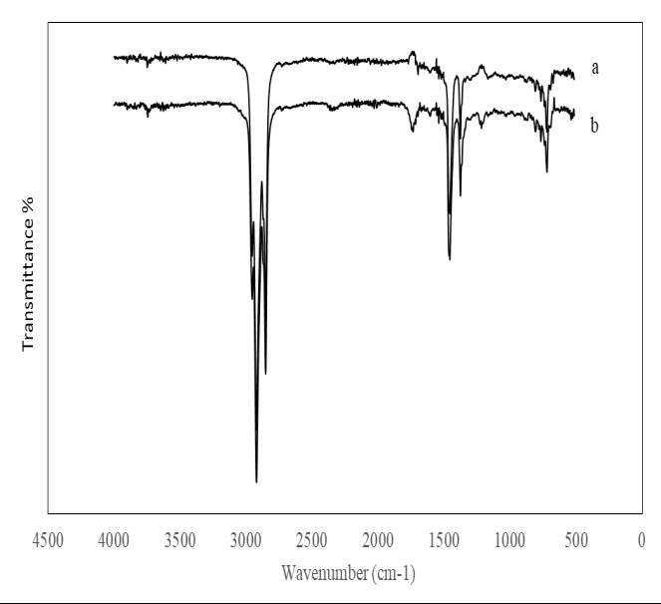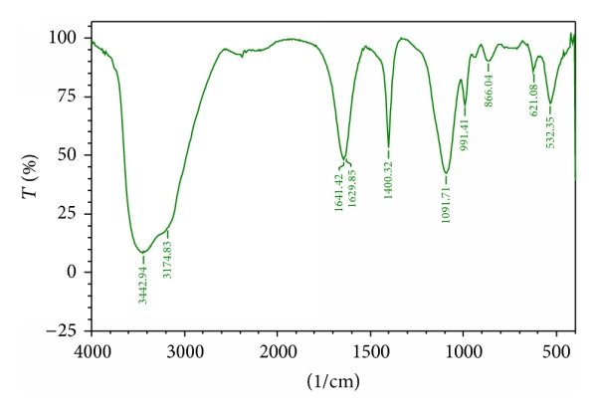
Fig.1 IR Spectra of hydrocarbon oil kerosene
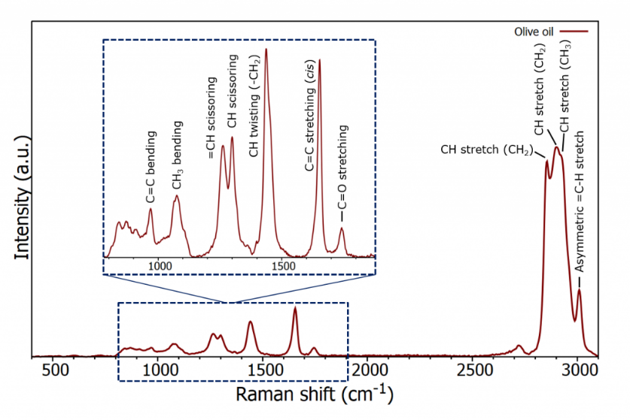
Fig.2 Raman Spectrum of Kerosene

FINGER PRINTING

Different methods have been adopted in the past to finger print the various samples (5-8). In finger printing of the sample, the computer calculates absorbance values from the transmittance values and converts them into pseudo-absorptivites

CONCLUSION

Identification IR and Raman Frequencies have been carried out using references (9,10). This investigations primely aims at the degradation of costal areas and marine eco system because seepage of oil spill during production. Tons of oil spilled in the ocean unnoticed and the same affect the coastal area. This investigation can also be enhanced by ATR Spectroscopy because normal IR method is opaque to aqueous solution.

Reference

- T.R.Crompton, 'Determination of Organic Samples in Water', Vol I (John Wiely & Sons; New York,Brisbane) (1985)
- R.Jeltes and W.A.M. Tonkelar,Water,5,288 (1972)
- J.A.Schuldiner, Analytical Chemistry,23,1976 (1951)
- P.F.Lynch and C.W.Brown, Environmental Sci. Tech., 7,1123 (1973)
- J.S.Mattson,Anal Chem., 43,1872 (1971)
- C.W.Brown,P.F.Lynch and M.Ahmadijian, Environmental Sci. Tech., 8,669 (1979
- C.W Brown,P.F.Lynch and M.Ahmadijian, Environmental Sci. Tech., 46,183 (1974
- F.K.Kawahara, Environmental Sci. Tech., 3,150 (1969)
- John R.Dyer,'Applications of Absorption Spectroscopy of Organic Compounds,(Printice Hall of India Private Limited) (1987)
- R.M. Silverstain and G.C Basslor, 'Spectrometric Identification of Organic Compounds,(John Wiley & Sons; New York) (1967)

